AROSE

Resource Collection I01
Duca abruzzi Libero Grassi – Italy

Summary
- No to Cyberbullying 2
- Let’s discover IPA 3
- What were you doing? 4
- Colour, Sound,Taste,And Smell 5
- Guess the object 6
- To be male or to be female? 7
- Speak Togheter 8
- Read & Speak 9
- A writing on my t-shirt 10
- Talking about personality 11
- A painting: “Mr and Mrs Clark and Percy” by David Hockney, 1971 (Tate Gallery, London) 12

Name of the activity | No to Cyberbullying
Level (CEFR) | ⬜A1 – ☑ A2 – ⬜ B1 - ⬜ B2
Objective(s) | Know, Understand and Reflect on cyberbullying topic;  Interview adults and peers.
Topic | Cyberbullying
Timing | 6 Hours
Resources/Tools | A Notepad, a pen.
Procedure | Creation of a mind map;  Creation of a wordlist;  Managing a guided conversation;  Writing some key questions;  Interview;  Taking notes of the replies;
Notes | The final step of this activity was the creation of a video to be shared with the Erasmus mates.

Name of the activity | Let’s discover IPA
Level (CEFR) | ⬜A1 – ☑ A2 – ⬜ B1 - ⬜ B2
Objective(s) | Learn and use the International Phonetic Alphabet so as to improve the pronunciation.
Topic | Any
Timing | 4 h total
Resources/Tools | The phonetic chart
Procedure | Presentation of the vowels and consonants’ symbols associated to each sound;  Reading of the sounds;  Looking for examples of known words;  Testing the sounds’identification of unknown words;  Creation of teams for a competition;  Real time feedback and correction;
Notes | Each team should have no more than 4 students.

Name of the activity | What were you doing?
Level (CEFR) | ⬜A1 – ☑ A2 – ⬜ B1 - ⬜ B2
Objective(s) | This activity can be adapted to revise a range of tenses (present simple, past simple, continuous, future tenses) by changing the time prompts, e.g. What are you going to do tomorrow / next weekend?
Topic | Past experience
Timing | 45 minutes
Resources/Tools | Whiteboard/paper/felt tips/pens
Procedure | - Write a selection of adjectives relating to feelings on the board.  - Tell students to choose several adjectives (increase or decrease the number depending on how long you want the activity to take). Tell them to think of a time when they felt this way, and that they are going to tell their partner / small group about their experience.  - Give students time to plan what they are going to say. They can make notes and ask for vocabulary if they want to.  - Students tell their stories  - Feedback to the class.
Notes

Name of the activity | Colour, Sound,Taste,And Smell
Level (CEFR) | ⬜A1 – ⬜ A2 – ☑ B1 - ⬜ B2
Objective(s) | To set up an intimate conversation
Topic | Memories
Timing | 20 minutes
Resources/Tools | none
Procedure | - Ask the students to do the following preliminaries:  - Clear the desks of books, papers, pens and bags  - Find a comfortable position in their chairs  - Relax (they can close their eyes if this heps)  - Listen to the teacher’s voice.  - Invite them to think back to a place which has been important to them in the past and concentrate on it for a few moments.  - The ask the students to remember a colour, a sound, a taste and a smell associated with that place.  - Then have them sit face to face in pairs and talk to each other about the special place and the sensations it invokes in them  - Do a round in which each person in turn describes the one colour, sound, taste or smell, which the activity has brought to mind most strongly.
Notes | It’s a good activity to use when the group is tired or needs a break from a day of intensive study.

Name of the activity | Guess the object
Level (CEFR) | ⬜A1 – ☑ A2 – ⬜ B1 - ⬜ B2
Objective(s) | This activity is good for activating existing vocabulary or revising vocabulary studied in previous lessons.
Topic | School equipment
Timing | 30 minutes
Resources/Tools | Whiteboard/paper/felt tips/pens
Procedure | - Tell students to write a list of ten words they associate with this topic. To make the activity shorter, reduce the number of words.  - Pre-teach or revise structures for definitions, e.g. It's a thing which / that ... You use it for ....  - Tell students to look at their lists and give them a few minutes to think of how they can define these words.  - Now students work in pairs (or groups of three) and define their words to each other. Their partner must guess the word they are defining.
Notes | This activity can suit different topics,e.g. students may be asked to guess celebrities, sports etc.

Name of the activity | To be male or to be female?
Level (CEFR) | ☑ B2
Objective(s) | Reflect on sex-assigned roles  Use of imaginative conditional  Discover stereotyping of male and female
Topic | Male and female roles and stereotypes
Timing
Resources/Tools | Pictures of people with various facial types
Procedure | Students will:  - complete orally sentences such as :  “If I were a man/boy – woman/girl, I would/ Iwould like to…”  “Why do you think you can not do ……?”  - start an open-discsussion of sex-assigned roles with other questions such as:  “ Which are the privileges and burdens of each sex?”  “ How do you perceive the division of roles between “sexes  - make a list of “ ways I have benefited by being a male/female today”  - discuss results in small groups
Notes

Name of the activity | Speak Togheter
Level (CEFR) | ☑ B1 - ⬜ B2
Objective(s) | Prepare an extensive speaking- monologue-  Plan an oral performance  Manage stress during an oral performance
Topic
Timing | 3 hours
Resources/Tools
Procedure | Performing the monologue using gestures and mimic if necessity.
Notes

Name of the activity | Read & Speak
Level (CEFR) | ☑A2 – ☑B1
Objective(s) | Developing reading aloud to improve English pronounciation, stress, intonation  Stimulating selfconfidence discovering his/her pace in speaking  Encouraging speaking  Learning a new vocabulary
Topic | any
Timing | 2 hours
Resources/Tools | Stimulating texts with different contents, different feelings and athmosphere
Procedure | Students will:  - Preview and read silently  - Listen to a model reading of the text  - Answer guided reading questions  Read aloud in front of the class  Students will evaluate the best reading
Notes | This activity can be easier or more difficult depending on the text chosen: difficult expressions, lenght of the text, topic……  Better not correct mistake during the performance

Name of the activity | A writing on my t-shirt
Level (CEFR) | A2 +/B1
Objective(s) | developing oral skills  increasing motivation in learning  building students' portfolio
Topic | Clothes /Personality
Timing | 50/60 minutes
Resources/Tools | A list of writings + research online + pen & paper
Procedure | The teacher asks, “If you had to put on a T-shirt with a writing on it, what would it be?”  1- Brainstorming: Whole-class speaking activity. Students are asked to express themselves.  2-The teacher gives a list of writings with a wide range of examples. Students read and translate the list in order to be inspired.  3- Students can choose from the list or are invited to do research online and find out the writing/s suitable to their personality.  4- Each student speaks and reveals his/her own writing to class.
Notes | This activity can be carried out at the beginning or at the end of a unit on clothes.  A list of popular writings on T-shirts – provided by the teacher:  Violence is never the answer.  I’m the king/queen of my life.  Never say never.  Music saved my life.  Take it easy.  Kindness will never go out of style.  Make love not war.  Nobody is perfect.  You reap what you sow.  Tell me and I forget. Teach me and I remember. Involve me and I learn (Benjamin Franklin).  Don’t be silly, put a condom on your willy.  All the world is a stage (W. Shakespeare).  I have a dream (Martin Luther King).  Italians do it better (Madonna).  If you want to go fast, go alone; if you want to go far, go together (African proverb).

Name of the activity | Talking about personality
Level (CEFR) | ☑ B1
Objective(s) | improving oral skills  increasing motivation  creating a warm and friendly atmosphere  developing reflective thinking  building students' portfolio
Topic | PERSONALITY TRAITS
Timing | 60 minutes
Resources/Tools | A series of questions provided by the teacher. Pen & paper
Procedure | - The teacher introduces the new topic showing a picture which contains 12 questions.  - Students take turn and are invited to speak and answer the questions. - The teacher writes their answers on the whiteboard and in the same time provides SS with useful terms & grammar structures to use. (e.g. Who is the most generous in the classroom?; I would like to be more.....; I woul like to be less....; etc.)  - Students answer the questions, listen to their classmates' answers, repeat the terms introduced by the teacher and take notes.  FOLLOW-UP ACTIVITY  -Students are invited to study their notes, all the questions & answers and write down a short composition about their personality to deliver to class.
Notes | 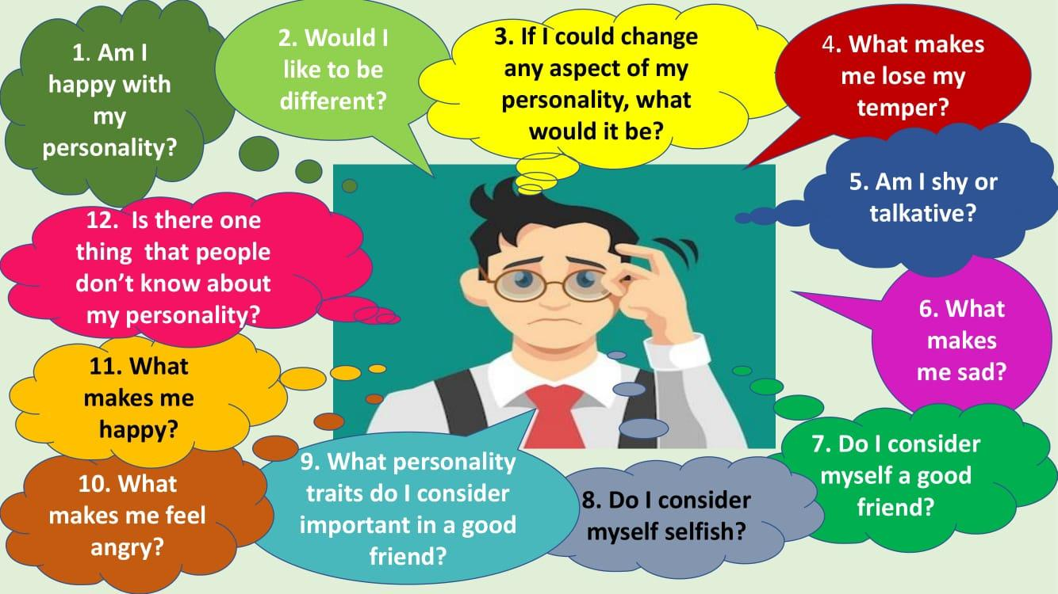

Name of the activity | A painting: “Mr and Mrs Clark and Percy” by David Hockney, 1971 (Tate Gallery, London)
Level (CEFR) | A2/A2+
Objective(s) | Describing a painting/picture  Use of there is /there are  Prepositions of place  Present continuous
Topic | DESCRIBING A PICTURE
Timing | 60 minutes
Resources/Tools | A picture of the painting  worksheet (prepsitions of place)  audio + worksheet (True/False activity)  script of the audio
Procedure | - The teacher introduces the painting.  - Students are given time to observe the painting.  - Exercise. Fill in the blanks with prepositions of place.  - True/False exercise: Students are given a worksheet containing 10 sentences. They have to listen twice to the presentation of the painting and then they have to decide whether the 10 sentences are true or false.  - At the end of the activities, students are given the script.
Notes | 